BSDB Gurdon Summer Studentship Report

I am Franklin Lo, a 4th year undergraduate student at the University of Edinburgh. My summer internship was carried out in Professor Sir John Gurdon’s lab at Gurdon Institute of the University of Cambridge and I was supervised by Professor Sir John Gurdon, Dr Jerome Jullien and Khayam Javed.

The major focus of my internship was to understand the functions of oocyte- specific B4 linker histone during nuclear reprogramming (NT). This maternal factor is abundant in oocytes and eggs, and present also in early embryo until the mid-blastula transition. The injection of somatic cell nuclei into Xenopus oocytes has been shown to reverse the restriction of some gene expressions and induce expression of pluripotency genes including POU5F1 and SOX2. This cell division independent process utilises components in the germinal vesicle (GV) of oocytes, and mechanism of reprogramming in NT is thought to be identical to the reprogramming of sperm genome by eggs after fertilisation. Therefore, NT is an excellent approach to gain further insights on the mechanism of nuclear reprogramming in eggs.

B4 is an important component of reprogramming by NT since it substitutes somatic histones in injected somatic cell genome and drives the transcription of pluripotency genes. A recently developed novel antibody-based methodology called Trim-Away enables targeting and degradation of specific proteins in Xenopus oocytes including B4 linker histone without any genetic manipulations. The procedure involves the injection of Trim 21 mRNA or protein into the cytoplasm or GV of oocytes, respectively, followed by GV injection of antibody specific to a maternal factor. The rationale of Trim-Away is that the constant region of antibody binding to its target protein interact with Trim 21 protein, which then recruits ubiquitin proteasome that degrades the protein-antibody-Trim21 complex (Fig. 1). By using this technique, we have targeted B4 linker histone to study the effect of its degradation on the efficacy of reprogramming after NT.

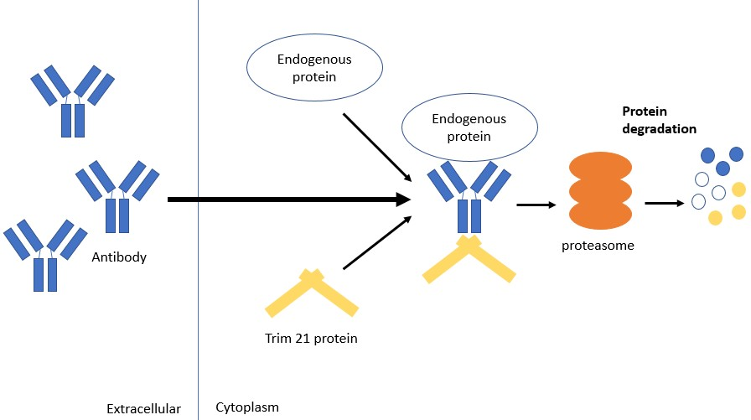

Figure 1. Mechanism of protein degradation by Trim-Away. The sophisticated characteristic of this method is its capability to knock down endogenous proteins such as maternal factors efficiently, which is not possible with techniques like gene editing and RNA interference

To perform these experiments, my first few weeks of the internship was dedicated on practising DNA/mRNA injection into the GV and cytoplasm of oocytes using Drummond microinjector under a light microscope. GV injection was especially a tough challenge for me since GV is hidden just underneath the pigmented region of Xenopus oocytes. A precise positioning of glass needle against oocytes and controlling the depth to penetrate are of utmost importance for successful GV injection. While my success rate began to hover around 50-60% after few weeks of practice, everyone else can aim the GV at approx. 90% efficiency! Such accuracy is important to run experiments smoothly. Nonetheless, I was compensating my inefficiency of GV injection by both increasing the number of oocytes I inject and co-injecting DNA encoding fluorescent protein which gives an indication of successful injection. Trim-Away is a very useful technique

and future attempts may involve targeting different maternal factors to study the mechanism of nuclear reprogramming.

I was also responsible for generating both Trim 21 fused with mCherry and B4 linker histone proteins using bacteria. It started off with cloning of these genes into an appropriate plasmid vectors and transforming it into a BL21 bacteria for protein expression. Protein purification worked but the yield was extremely lower than our prediction. After numerous attempts, we managed to produce a large quantity of these proteins using a strain of bacteria called Rosetta. I still remember the joy of seeing pink bacterial culture as Rosetta strain was highly expressing Trim 21- mCherry (Fig. 2). Unfortunately, my time in the lab was limited and I could not purify these proteins.

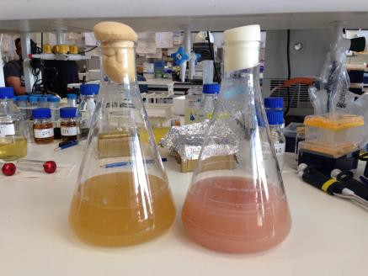
Figure 2. Protein expression using Rosetta strain. Trim21-mCherry production (right) turns bacterial culture medium pink while wild type B4 protein (left) production did not change the colour of culture medium.

Having gained experiences to work with oocytes, I also began to work with Xenopus embryos which is made by fertilising eggs with sperms extracted from testis. Oocytes and eggs are naturally protected by a jelly-like coating which impede penetration of resulting embryos with a microinjector. But unlike oocytes, de-jellying process of embryos are difficult, and I often killed the embryos by de-jellying excessively. The unusual hot weather in Cambridge also deteriorated the egg quality and heightened the difficulty of working with embryos; researchers working with Xenopus often avoid performing important experiments during the summer. The time frame for injection is also shorter in embryos since they divide and develop, hence time window for injection is shorter than oocytes which are static. Despite

encountering these challenges, I still found experiments with embryos very exciting as mRNA injected can affect embryo development and produce unique phenotypes.

Despite being a Nobel laureate, professor Gurdon is always humble and
active as a researcher - he is very focused and still loves to perform
experiments. Everyone, including myself, gains strong motivations to
work hard from seeing his working style. His talkative and approachable
personality makes him a great researcher even more; he often taught me
procedures to work with oocytes and invited me to his tea-time for further
discussions.

I was also surprised to see that everyone in the lab is very enthusiastic and keen about learning new information even from outside of their field of interest. This nature must be acting as a strong foundation for them to come up with creative ideas. The experience I had at Gurdon lab was stimulating and fantastic, I very much appreciate mentorship, patience and kindness from Professor Gurdon, Jerome and Khayam. Working closely with several supervisors enabled me to participate on multiple projects and gain a variety of invaluable experiences.

I would also like to convey my gratitude to other lab members namely, Nigel Garrett, Can Aztekin, Dr Eva Hörmanseder, Dr Ming-Hsuan Wen, Dr Chris Penfold and Dilly Bradford for their immense support and mentorship during the internship.

Finally, I would like to thank BSDB for providing me this opportunity and I strongly recommend students who wish to do a lab internship to apply for this studentship. It offers students to gain hand-on experiences in an exciting lab!

